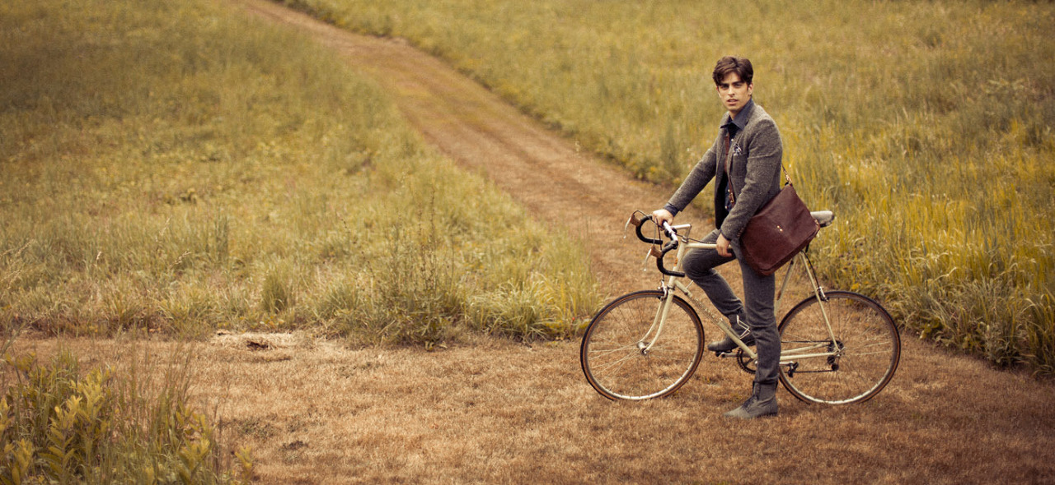

Photograph by Eric Ryan Anderson

I love this photo for nothing other than the simplicity and emption it captures. It uses the rule of thirds in a 16:9 aspect ratio photograph, but the added width doesn't take away from the image. Having the path lead off into the background draws your eye up and down the photo bringing you directly to the man on the bike. The field and cut grass path have a very similar coloring and subtle contrast, but it is just enough to capture your attention. This image really made me wonder, why is he on this path? He doesn't seem to be biking as a hobby as he is fairly well dressed, and a satchel isn't something you would usually bring along too. He doesn't show too much obvious emotion so it really leaves the viewer to think.